Дата: 03.06.2022 Клас: 4-А, Б (1 група)

Предмет : Англійська мова Вчитель: Глуговська Л.Г.

**Тема: Діагностична робота №10**

**Хід уроку**

***1. Warming up and reviewing (Розминка)***

***- Hello, children! How are you?***

***Ask and answer the questions.***

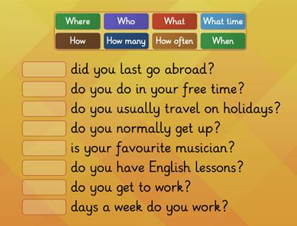

1. **Reading**

Прочитайте діалог.

Ann: My granny is going to visit me tomorrow!

Megan: WOW! Is she going to come by bus or train?

Ann: By train. She asked to meet her at the railway station at 4 o’clock. Megan: It’s good. Travelling by train is faster than travelling by bus.

Ann: Look at the on-line information desk! When does her train arrive? And which platform?

Megan: The train arrives at 3:45. It arrives at platform 2.

1. **Writing**

Friday, the third of June

Control test

1. **Прочитавши діалог, познач правильні твердження.**

1. Ann’s granny is going to visit her next summer.

2. She is going to come by train.

3. Ann’s granny asked to meet her at the airport at 4 o’clock.

4. Travelling by train is faster than travelling by bus.

5. Her train arrives at 3:45.

6. The train arrives at platform 3.

1. **Розглянь малюнки, розкажи куди і чим планують подорожувати діти.**

**Наприклад:** - John is going to travel to England by boat.

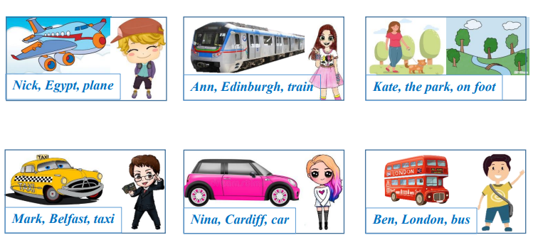

1. **Дай відповіді на питання. Користуйся словами з рамочки.**



1. What is the symbol of Ukraine?

2. What is the symbol of England?

3. What is the symbol of Scotland?

4. What is the symbol of Wales?

5. What is the capital of Scotland?

6. What is the capital of Great Britain?

1. ***Homework***

Домашнє завдання:

1. Зробити всі завдання діагностичної роботи письмово.

**Надіслати виконані вправи у Вайбер (0964124047) – Людмила Григорівна або прикріпити на Human.**